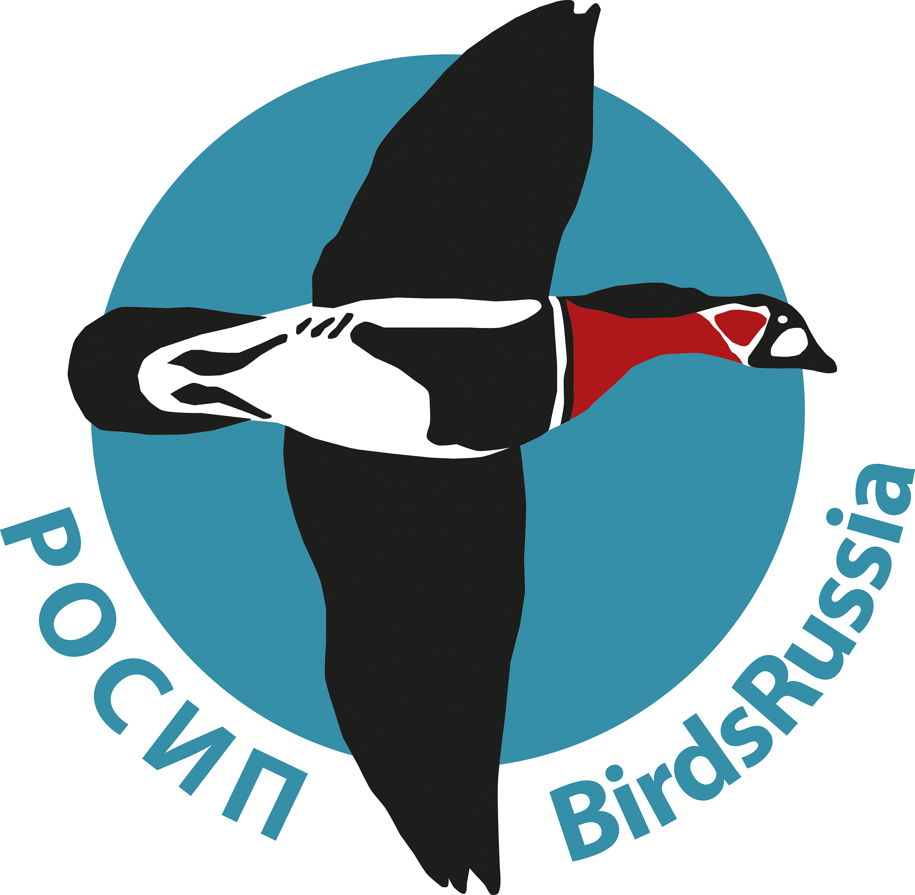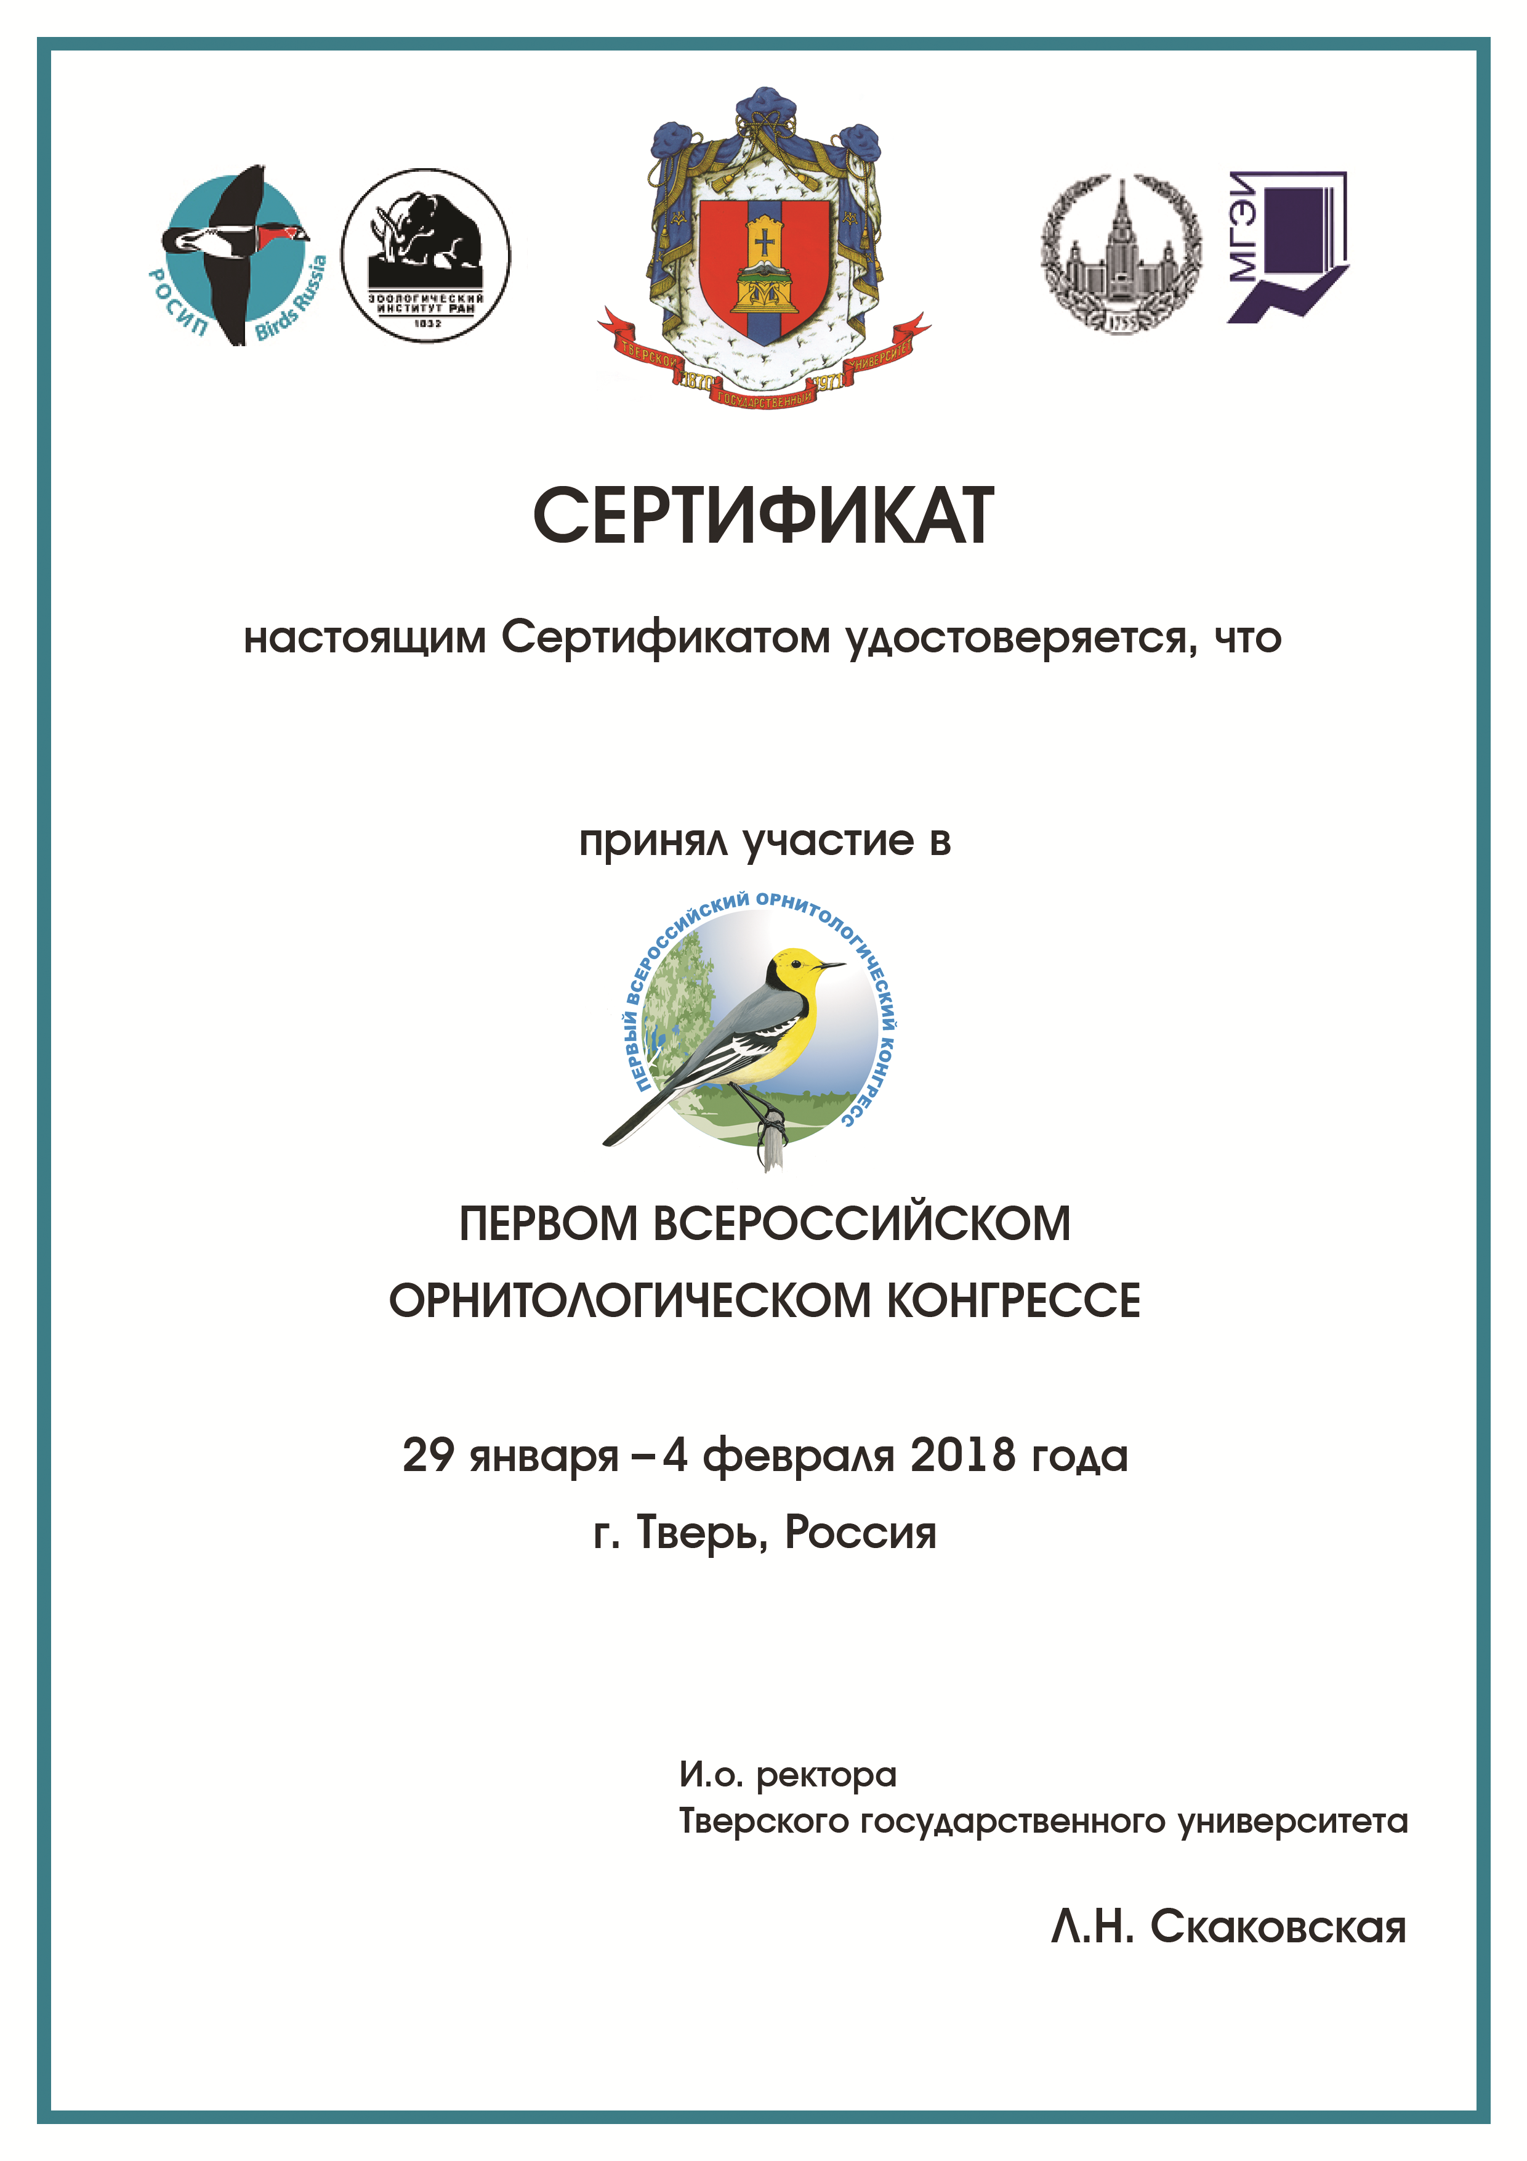

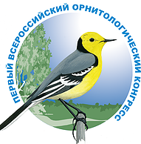

Workshop «Status and Conservation Planning for Yellow-Breasted Bunting in Russia”, January 28-29, 2018. Address: Tver, Dmitry Donskoy str., 37,
Tver branch of Moscow Humanitarian-Economic Institute

Programme

28.01.2018
13:00-14:00 Registration for the ROC and workshop
14:00 -16:00 Opening Session: Global reasons of decline and conservation priorities for Yellow-Breasted Bunting
Conveners: Syroechkovskiy E., Mischenko A.
14:00-14:10 Syroechkovskiy E. E. Welcome speech on behalf of ROC organizing committee. Workshop goals: the importance of Yellow-Breasted Bunting as a flagship species for conservation of landbird migrants in the East Asia.
14:10-14:15 Welcome speech on behalf of Russian Ministry of Nature Resources.
14:15-14:20 Mischenko A. L. Welcome speech of vice-president of Birds.
14:20-14:25 S. Chan. Welcome speech from BirdLife International.
14:25-14:40 S. Chan. The Guangzhou Yellow-Breasted Bunting Workshop (November 2016) and beyond.
14:45-15:00 J. Kamp. Global population trend and potential reasons for the decline of the Yellow-Breasted bunting - an update.
15:05-15:20 Burskiy O. V. Multiple causes of Yellow-Breasted Bunting decline.
15:25-15:40 Mischenko A. L. Yellow-breasted Bunting in European Russia: the story of ups and downs.
15:45-16:00 Anisimov Yu. A. Establishment of Russian network for monitoring of population trends of Yellow-Breasted Bunting and other landbird species as a part of a larger Asian network.
16:05-16:20 Coffee break
16:20 -17:00 Status and trends of Yellow-Breasted Bunting in regions of Russia
Conveners: Gerasimov Yu. N., Ktitorov P. S.
16:20-16:25 Yakovlev V. O. Short communication on the Yellow-Breasted bunting survey on Chukotka.
16:30-16:40 Preobrazhenskaya E. S. Records of Yellow-Breasted Bunting in the river valleys of Onega, Dvina, Pinega and Mezen at 2013-2017.
16:45-16:55 Melnikov V. N. Yellow-Breasted Bunting in the Eastern Verkhnevolzhye.

17:00-18:00 Discussion: Global reasons of Yellow-Breasted Bunting decline, establishment of database for Yellow-Breasted bunting and other songbird species. Conveners: Anisimov Y. A., Syroechkovskiy E. E.

29.01.2018
09:00-13:15 Subspecies taxonomy, distribution and trends of different populations of Yellow-Breasted Bunting
Conveners: Burskiy O. V., Anisimov Yu. A.
09:00-09:15 Redkin Ya. A. Subspecies of Yellow-Breasted Bunting Ocyris aureolus (Pallas, 1773).
09:20-09:35 К. Ozaki. Declining of Yellow-breasted and Rustic Bunting in Japan.
09:40-09:55 Valchuk O. P. Monitoring of Yellow-Breasted Bunting in some parts of Easten and central Sakhalin and Southern Primorie before and after uplisting to IUCN threatened category.
10:00-10:15 Ktitorov P. S. Current distribution of Yellow Breasted Bunting on Sakhalin island: shift to the north or extinction in the south?
10:20-10:35 Kolbin V. A. Numbers of Yellow-Breasted Bunting around Nature Reserves Vishersky (Perm region) and Norsky (Amur region) up to 2013, Komsomolsky (Khabarovsk region) till 1994.
10:40-10:55 Durnev Yu. A. Yellow-Breasted Bunting in Baikal region: species ecology and new data on numbers.
11:00-11:20 Coffee break
Conveners: Durnev Yu. A., Anisimova O. Yu.
11:20-11:35 Gerasimov Yu. N. Yellow-Breasted Bunting on Kamchatka.
11:40-11:55 Smirensky S. M. Muraviovka park – refugium, origin of renaissance, or one more site for local extinction of Yellow-Breasted Bunting?
12:00-12:15 W. Heim. Migration and wintering of the Yellow-Breasted Bunting from Amurland: New insight from colour-ringing and geolocator studies.
12:20-12:35 Antonov A. I. Dynamic of breeding population of Yellow-Breasted Bunting in the south of Amur Region.
12:40-12:55 Amosov P. N. Dynamic and current numbers of Yellow-Breasted Bunting in Arkhangelsk Region.
13:00-13:15 Bekmansurov R. H. On the need in ban of trapping for captivity and trading of Yellow-Breasted Bunting in Russia.
13:15-13:40 Additional talks of participants.
13:40-14:40 Lunch
14:40-16:30 Discussion: regional features of changes in numbers of Yellow-Breasted Bunting, proposed conservation actions and suggestions for the draft of Action Plan for Yellow-Breasted Bunting Conveners: Ktitorov P. S., Anisimov Yu. A.

The workshop organized by BirdsRussia as a part of collaboration with BirdLife Inetrnational-Asia, it is national meeting for development of International Action Plan for Yellow-Breasted Bunting Conservation.
The Action Plan will be developed under umbrella of CMS with involvement of non-CMS parties countries, including Russia, with reference to uplisting of the species to Critically Endangered category of IUCN Red List, caused by 80% decline of the world population during the last 20 years.
Coordinators of BirdsRussia project for conservation of Yellow-Breasted Bunting in Russia and organizers of the workshop are A. L. Mischenko (vice-president of BirdsRussia), P. S. Ktitorov (head of Sakhalin branch of Birds Russia), Y. A. Anisimov (head of Baikal branch of BirdsRussia).

